Saulo Moreira da Silva

Ksenia Studilina

Project proposal

**Bank management system**

**Project description**

*Bank Management System* will be a Windows desktop application designed by Ksenia Studilina and Saulo Moreira da Silva in C# programming language using the Visual Studio software. The main goal of this intended program is to facilitate management of all customer/account/transaction related activities performed by a branch representative.

The software in its first version will contain four main sections: 1) Manage clients, 2) Manage Accounts, 3) Perform Transactions and 4) Generate reports. The first section will allow the branch representative to create new profiles for the bank (from new customers), as well as update any information (like an address change, for example) or even delete a client who is no longer doing business with the bank.

   In the second section (Manage Accounts), the branch representative will have the power to add a new account to the customer’s profile or update anything related to it; while in the third section, through client’s authorization, he or she would be able to perform transactions such as deposit, withdrawal and transfer to another account. Finally, the last section will be useful to generate reports such as Statement and possibly also credit score, among others.

**Technologies used**

* WPF, C#
* SQL Database (Azure)
* Entity Framework
* StackPanel
* iText 5 .NET PDF library
* Printing using WPF
* Installer

**Database design**

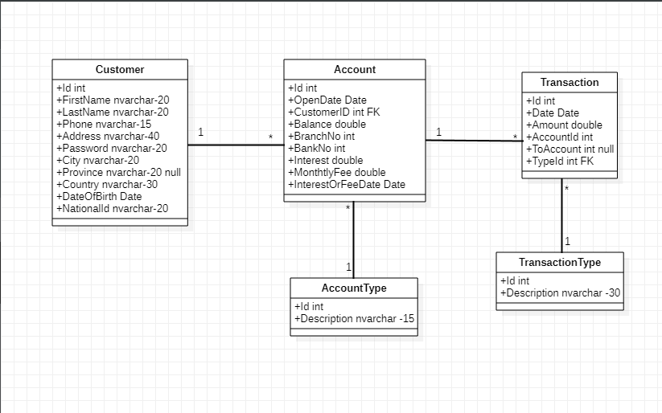

**Application mockups**

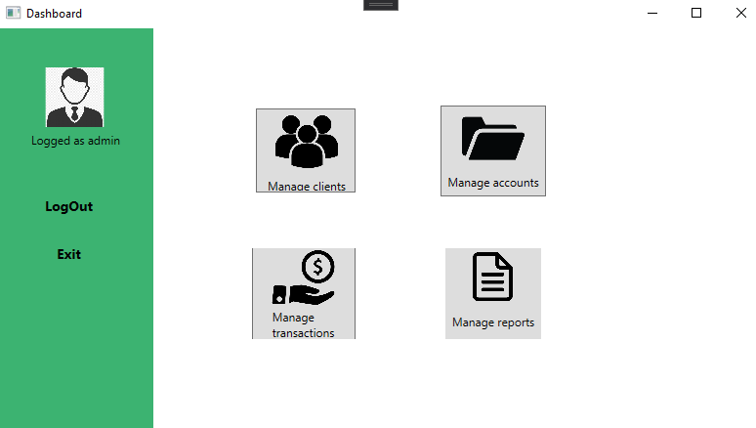Dashboard (main window)

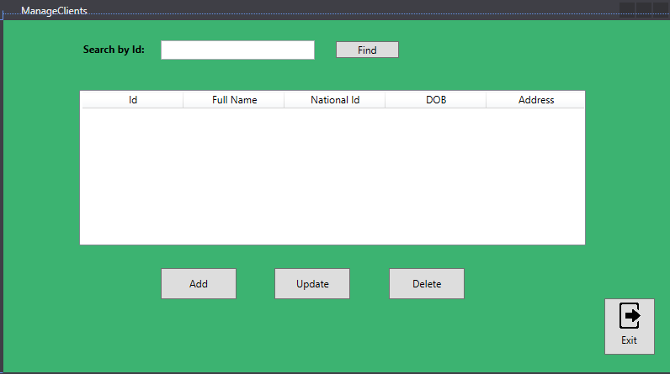Manage customers

Add new customer

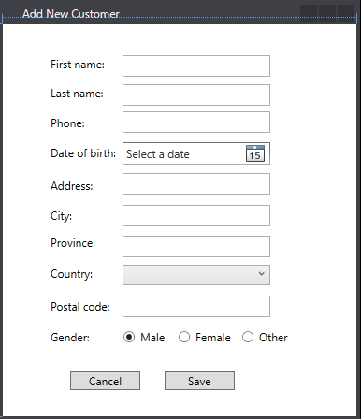

Manage accounts

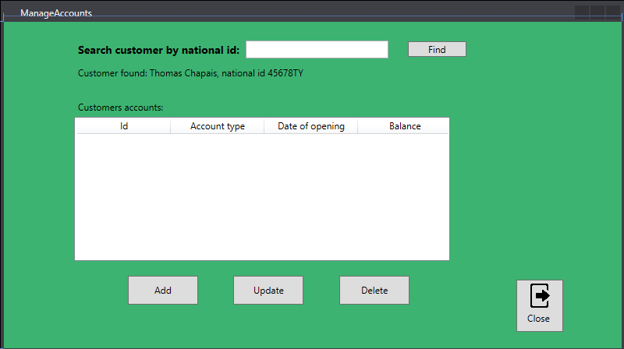

Manage transactions

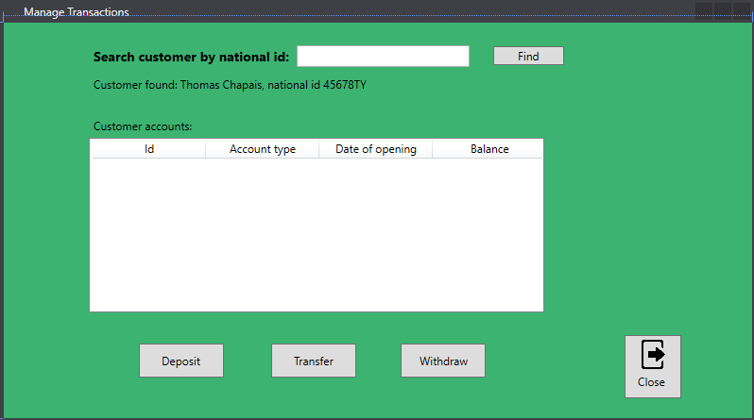

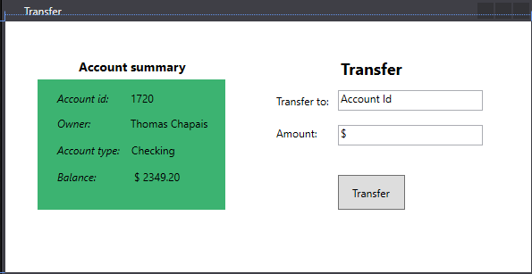

Transfer